Arushi Singh Mob No:-999999999
Arushi Beauty Parlour
Unisex Salon and Spa
A/12, Shenik Park, Opp. Jain Mandir, Ashok Nagar, Muradabad-656521

No. Date…………………………...

Name…………………………………………………………………. Mob No………………………..

Sr No | Description | Qty | Rate | Amount
 | 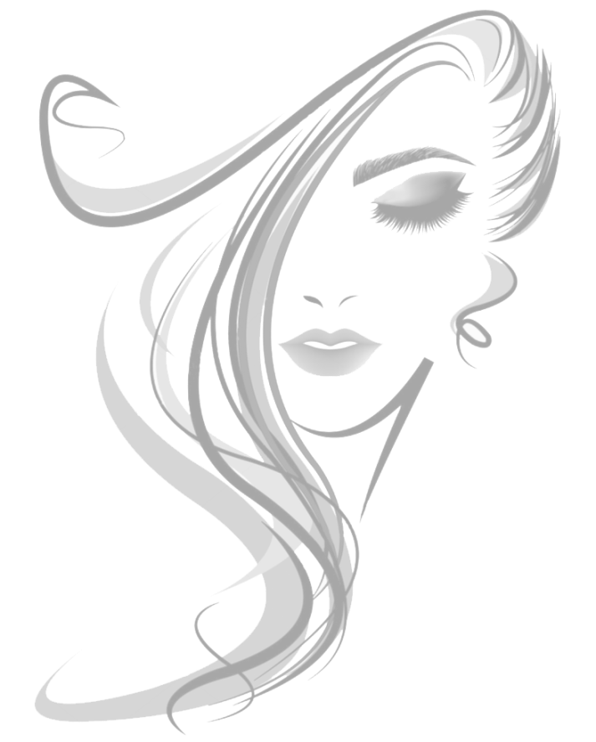
Amount In Word |  | Sub Total
 |  | Bill Discount
 |  | Net Amount

Term & Condition:-
- Subject to Moradabad Jurisdictions
For Arushi Beauty Parlour
Signatory
- Product Result as per manufacture’ guides.

